

Welcome to the Center for California Real Estate's (CCRE) monthly marketing toolkit of slides, social posts and additional resources exploring consumer issues in residential real estate. ​​​​Download ​​​​these data-driven tools to enhance your marketing plans and spark conversations in your spheres of influence.
This month, we’re looking at how to serve the military veteran homebuyer. Veterans often rank the VA home loan as the top benefit they receive as a result of their service, and many seek to partner with REALTORS® as they transition to civilian life and explore homeownership.
Despite being held in high regard by most Americans, 84% of veterans report that the general public has little understanding of their needs. We’ve created this toolkit to help you become a trusted guide to veterans throughout the homebuying process.

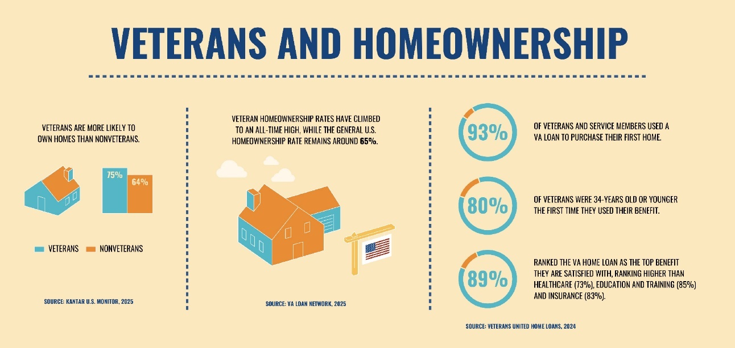

SLIDE DECK: Homeownership rates for veterans continue to climb, and veterans tend to become homeowners at a younger age than nonveterans.
Download and insert these slides into a listing presentation for military clients. View the deck as a slide show in your next office meeting to brainstorm marketing to clients worried about the economy.

 |  |  | SOCIAL MEDIA POSTS: Download and share these social posts to serve the military veterans in your community.
 | INFOGRAPHIC:  Share 7 Facts about Military Veterans REALTORS® Need to Know, featuring space for your contact info. |  | 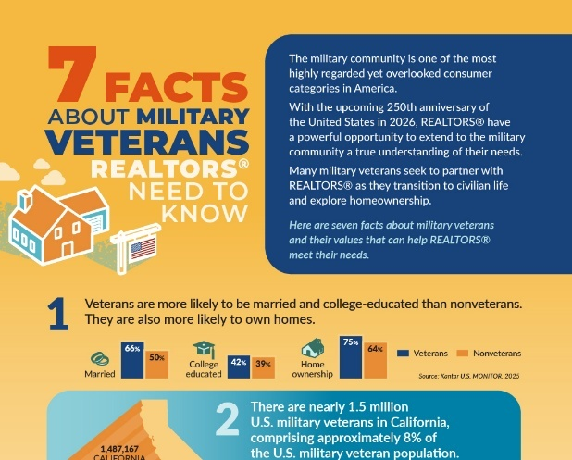

 | TOP 5 TAKEAWAYS: Consider these key points to help attract and guide military veteran clients.
 |  |  | The military offers unique benefits that encourage homeownership among veterans. Veterans often rank the VA home loan as the top benefit they receive as a result of their service.
 |  |  | Most Americans hold the military in high regard, but most veterans feel the general population doesn’t understand their needs.
 |  |  | ​​Veterans prioritize having a sense of control and stability in their lives. They score higher on financial well-being scales than nonveterans.
 |  |  | Veterans have a heightened sense of responsibility. They vote more often than nonveterans and are more likely to be employed in managerial positions.
 |  |  | Surveys find that veteran consumers prioritize connection — specifically how well businesses understand the military community. C.A.R. resources can help you become a trusted guide to veterans during the homebuying process.

Missed an issue? Visit the Consumer Trends and Insights archive on the CCRE website.
Disclaimer: Use of the materials contained in CCRE Consumer Trends and Insights must include proper attribution to Kantar, LLC. Attribution is already built into the downloadable tools, and members are asked not to remove or alter these credits when sharing with clients or the public.

This message was sent to %%email%%. Visit your subscription management page to unsubscribe or modify your email communication preferences. To update the email address to which this newsletter is sent, please contact your local association.
Advertising Inquiries: learn how you can advertise in this email newsletter.
CALIFORNIA ASSOCIATION OF REALTORS® • 915 L Street, #1460, Sacramento, CA 95814
Copyright © 2025, All rights reserved.

