

Welcome to the Center for California Real Estate's (CCRE) monthly marketing toolkit of slides, social posts and additional resources exploring consumer issues in residential real estate. ​​​​Download ​​​​these data-driven tools to enhance your marketing plans and spark conversations in your spheres of influence.
Homebuyers are increasingly interested in sustainability features--especially those that result in cost savings, such as WaterSense fixtures, solar panels, and climate resilience efforts that may lower insurance premiums.
As their REALTOR®, you can connect them to homes that can result in financial savings, better health and increased resilience amid extreme weather and natural disasters. For today's consumers, your ability to lead the sustainability conversation is a key component of your REALTOR® value. We’ve created this toolkit to help you become a trusted guide on sustainability and homeownership in 2025.

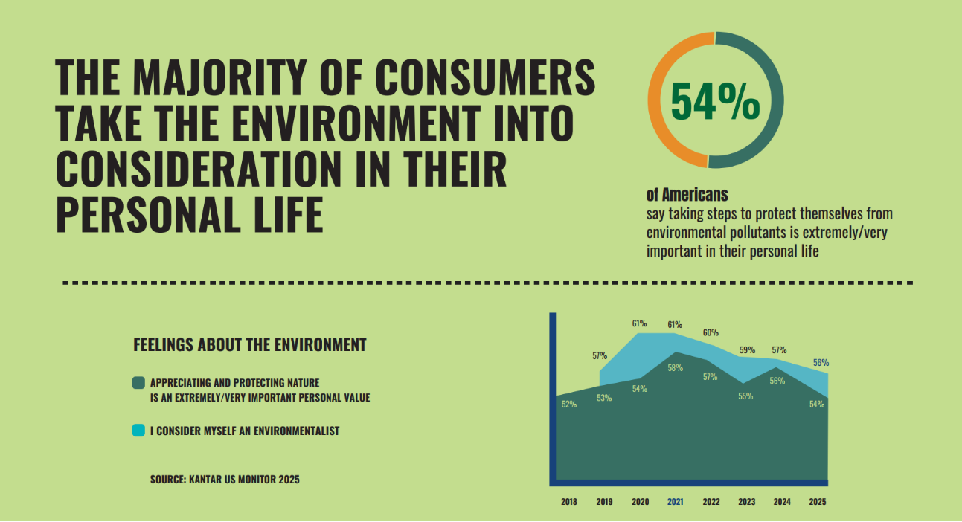

SLIDE DECK: Homebuyers increasingly ask about sustainability features during their search, and homes with desirable sustainability features command higher sales prices.
Download and insert these slides into a listing presentation to help clients market their homes' features. View them as a slide show in your next office meeting to learn how to lead client conversations about sustainability.

 | 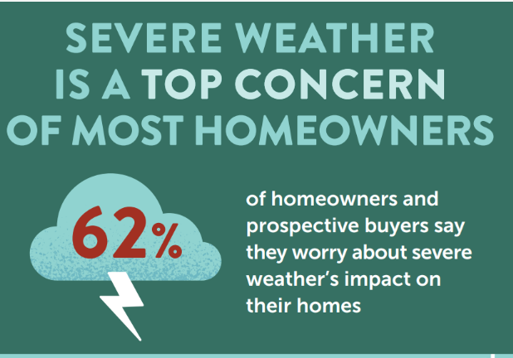 |  | SOCIAL MEDIA POSTS: Download and share these social posts to attract clients motivated by sustainability features.
 | CONSUMER GUIDE:  Share The Green Home Essentials: 5 Sustainability Metrics Every Homebuyer Must Know. |  | 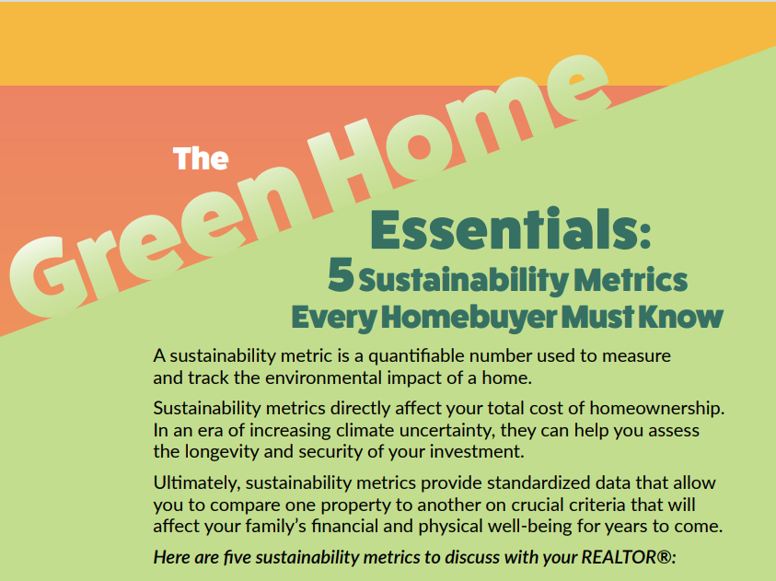
 | 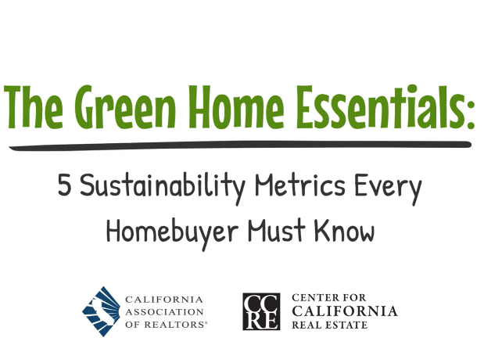 |  | CONSUMER VIDEO: ​​​  Share this two-minute video version of The Green Home Essentials: 5 Sustainability Metrics Every Homebuyer Must Know.

 | TOP 5 TAKEAWAYS: Consider these key points as you navigate clients' sustainability needs.
 |  |  | The majority (70%) of prospective homebuyers consider sustainability features, such as solar panels and WaterSense fixtures, when buying a home.
 |  |  | Once the priorities of affluent buyers, sustainability features are now seen as keys to cost savings​. Thirty percent (30%) of REALTORS® say consumer awareness of energy cost savings is a key driver for sustainable-home demand.
 |  |  | The financial impact of severe weather weighs on clients’ minds. Seventy-three percent (73%) of homebuyers consider the importance of purchasing in areas with lower severe weather risks.​
 |  |  | The green data fields in the MLS are important tools to match clients to sustainability features. Nearly half of REALTORS® neglect to fill these in.
 |  |  | Today’s homebuyers think about practical sustainability issues such as water conservation, climate resilience, and energy costs. REALTORS® who respond with concrete, measurable benefits (lower utility bills, decreased insurance premiums from climate resilience efforts) are showing true REALTOR® value.

Missed an issue? Visit the Consumer Trends and Insights archive on the CCRE website.
Disclaimer: Use of the materials contained in CCRE Consumer Trends and Insights must include proper attribution to Kantar, LLC. Attribution is already built into the downloadable tools, and members are asked not to remove or alter these credits when sharing with clients or the public.

This message was sent to %%email%%. Visit your subscription management page to unsubscribe or modify your email communication preferences. To update the email address to which this newsletter is sent, please contact your local association.
Advertising Inquiries: learn how you can advertise in this email newsletter.
CALIFORNIA ASSOCIATION OF REALTORS® • 915 L Street, #1460, Sacramento, CA 95814
Copyright © 2025 All rights reserved.

